PRESS RELEASE JDN116

NEW FINISH FOR VERSATILE HOIST RANGE
IS ENVIRONMENT OPTIMIZED

J D Neuhaus (JDN) is implementing a new Hydro Coating on its industry-leading hoist range. The coating not only enhances quality and appearance, but is far more environmentally friendly.

JDN takes its corporate and social responsibilities extremely seriously, and moving from a standard hammer finish to the Hydro Coating will contribute to sustainable protection of the environment. In fact, the new Hydro Coating features a percentage of organic solvents that is less than 3%, which is significantly more environmentally-friendly than the former hammer finish. In addition, the coating is silicone-free, which means no wetting failures, an important consideration for automotive or coating plants.

Further benefits of the Hydro Coating include optimized adhesion, high resistance to corrosion and oil, and the potential to be diluted with water if required. It offers excellent surface quality, even when refitting, and complies fully with the VOC (Volatile Organic Compounds) Directive.

JDN’s lifting equipment is designed to be used in the world’s toughest operating conditions, a fact supported by the company’s mantra of ‘engineered for extremes’. In sectors such as mining, offshore, energy, chemical and construction, safety is the number one priority. From an equipment perspective, this means reliability and robust manufacture, as the margins for failure are typically zero, particularly in long-lift and/or repetitive cycling applications.

Continued ……
In addition, the hoists are rated for use in explosion and hazardous dust-laden areas up to ATEX Zone 2, with even higher classifications available upon request. This means that JDN equipment will not generate any sparks or electrostatic discharge.

JDN hoists are also required to offer full functionality at all times, regardless of the presence of contaminants such as dust, dirt, heat, cold or seawater. As a result, each component is actually manufactured to a level beyond its standard specification and rigorously tested to ensure that both performance and quality are maximised. In turn, this renders the hoists ideal for use in a wide variety of industries, from automotive, shipbuilding and steelmaking, through to food, glass, leather, printing and papermaking.

JDN’s hoists, such as the company’s class-leading air-powered Profi range is available with various control systems and load capacities from 550lbs up to an impressive 100T. Alternatively, JDN’s hydraulic powered Profi hoists can be deployed, which are available from 3T up to 100T in lift capacity. Alternatively, the Monorail hoist series is ideal for low-headroom as well as heavy-load applications. The pneumatic Monorail series covers carrying capacities from 10T to 115T, while units from 20T to 100T are also available with hydraulic drives.

Among the latest developments to the JDN range of hoists and cranes is a robust new control concept. The company’s JDN-RC (Radio Control) features a solid and extremely compact receiver to suit even hoists with low-carrying capacity. The receiver can be mounted on the hoist or trolley, or at a separate location, in line with specific customer requirements. It allows users to work at a safe distance from the load and take a better viewpoint during operations. Furthermore, the control is ideal for spanning long distances between the hoist and the operator, and represents a sensible alternative to applications demanding a long control hose. The receiver is suitable for use in harsh operating environments, including ATEX (explosive atmosphere) zone 2/22 conditions.

Continued ……
A further recent innovation is the introduction of a range of C rail and light crane systems for operation with the company’s established and successful mini air hoist range. Both the C rail/suspension tracks and the light crane systems are rated for use in explosion and hazardous dust-laden areas up to ATEX Zone 2, 22. Featuring high quality standard elements, the modular C rail systems/suspension tracks make for smooth movement of loads in accordance with individual customer requirements. Also offering modularity, the light crane systems adapt easily to load and operating conditions, and are available in four standard profile sizes that provide smooth movement of the reinforced crane bridge.

Company Information
With over 200 employees across the group, J D Neuhaus manufactures pneumatically and hydraulically-operated hoists and crane systems up to 115 metric ton capacity from its state-of-the-art facility in Witten, Germany. This globally unique specialization means that J D Neuhaus has set the quality standard for the market, a move that has seen the company become the established global leader in its technology field with customers in more than 90 countries worldwide.

Resilience and reliability are the key product differentiators, thanks largely to their explosive protection rating which makes them ideal for use even in the most challenging of operating environments. Extreme applications include oil and gas exploration in arctic temperatures as low as -45°C, along with underwater tasks such as ship hull repairs, and plenty of others in demanding sectors like mining, the chemical industry, heavy plant construction and many areas of logistics.

The wide portfolio of services provided by J D Neuhaus includes equipment assembly, inspection, maintenance and general overhaul, along with the supply of customer training courses.

Over 80% of production from the Witten plant is exported, which is why the company has long-established subsidiary companies in France, Great Britain, Singapore and the USA, all of which have helped create a tight-knit global network in collaboration with international partners.

Continued ……
J D Neuhaus has history that can be traced back to 1745, and is now in its seventh generation of family ownership. Visitors to the Hebezeug-Museum (Hoist Museum) in Witten, are able to see for themselves the remarkable history of this progressive company.

Further information is available on request to:
J D Neuhaus L.P., 9 Loveton Circle, MD 21152 Sparks, USA
Contact: Peggy Weber e-mail: p.weber@jdneuhaus.com
Office Phone: 1-888- NEUHAUS www.jdngroup.com

Worldwide contact details for J D Neuhaus can be seen at the end of this press release.

facebook.com/jdneuhaus twitter.com/JD_Neuhaus

(approximately 1010 words
including photographic annotations)

General Information

Supplier: J D Neuhaus L.P.

Press Release No: JDN116

Press or publishing inquiries to: Steve Lloyd
Enterprise Marketing Services Ltd
The Coach House, 1 Dunstall Road, Barton under Needwood,
Burton on Trent, Staffordshire, DE13 8AX, UK
Tel: +44 (0) 1283 713185
Fax: +44 (0) 1283 716172
e-mail: info@enterprise-marketing.co.uk

Reader response inquiries to: Ms Peggy Weber of J D Neuhaus L.P.

Downloads: The press release text (MS Word and PDF format) and images are
available for download at:

www.enterprise-marketing.co.uk/jdn/jdn116.html

Our Reference: JDN116/17/05/V4

Continued ……
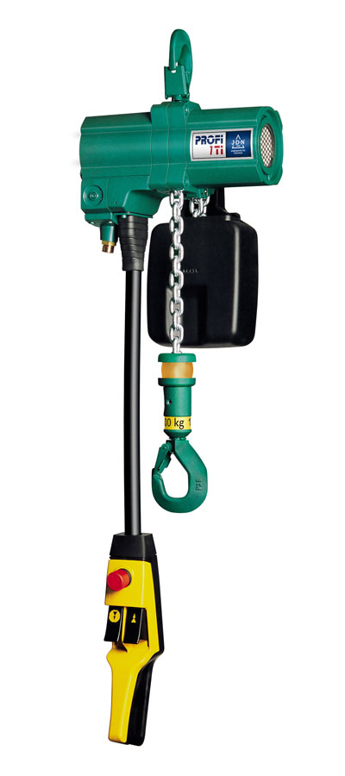
The Profi range of hoists from J D Neuhaus will now have a more environmentally friendly Hydro Coating.
Download high resolution 300dpi image (1200 x 2700 px)
Download low resolution 72dpi image 400 x 900 px)

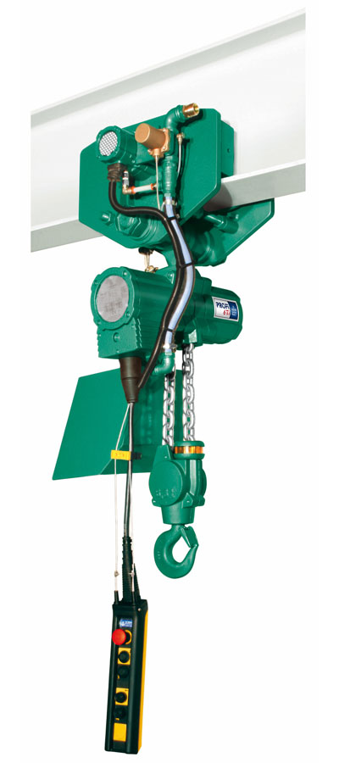
A Profi 6 TI hoist shown in motor trolley, just one of the range of J D Neuhaus products to feature the new Hydro Coating.
Download high resolution 300dpi image (1200 x 2700 px)
Download low resolution 72dpi image 400 x 900 px)
Continued ……
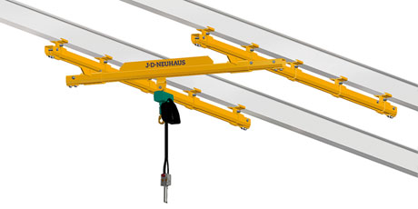
The J D Neuhaus C rail and light crane systems are suitable for use in explosion and hazardous dust-laden areas up to ATEX Zone 2, 22.
Download high resolution 300dpi image (2400 x 1200 px)
Download low resolution 72dpi image 800 x 400 px)

Continued ……
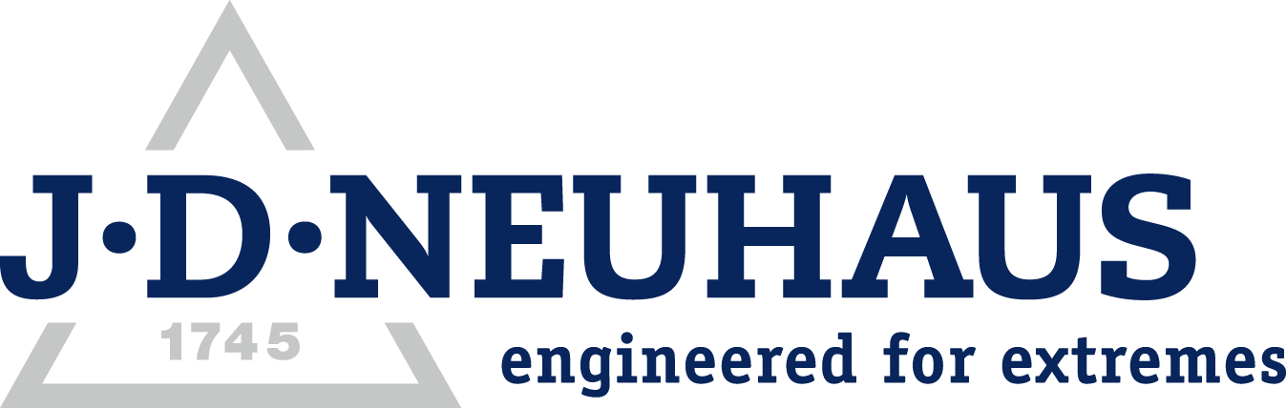
Company information

J D Neuhaus are a privately-owned company, founded in 1745, and for over 270 years they have been using their expertise and experience to manufacture the highest quality hoists and cranes.

Their products offer solutions to almost every material handling problem irrespective of the driving medium: from air and hydraulic hoists up to complete crane installations with explosion proofness.

JDN products are used in a wide variety of industries including:
Airplane Yards; Atomic/Coal Power Stations; Big Bag Handling; Cement Industry; Chemical Industry;
Crane Manufacturers; Dairies; Food Industry; Foundries; Galvanization; Glass/Ceramics; Large Kitchens;
Leather Plants; Locks; Machine and Plant Construction; Mining; Motor Car Industry; Offshore/Onshore;
Oil Storage; Over/Underground Construction; Paints and Varnish; Painting and Coating Installations;
Paper Industry; Pharmaceutical Industry; Printing Industry; Pyrotechnics Industries; Refineries; Sawmills; Shipbuilding and Shiprepair Yards; Ships; Space Technique; Spray Booths; Steel Works; Surface Technique;
Tank Cleaning Devices; Textile Industry; Tunnel; Tire Manufacturers; Vacuum Technique

Contact J D Neuhaus

J D Neuhaus are represented in more than 90 countries and over 70 branches Worldwide.

Germany
J D Neuhaus GmbH & Co. KG, 58449, Witten-Heven, Germany
Tel: +49 2302 208-219 Fax: +49 2302 208-286
e-mail: info@jdngroup.com www.jdngroup.com

France
J D Neuhaus S.A.R.L., 24, rue du Président Krüger, 69008, Lyon, France
Tel: +33 4 3790-1745 Fax: +33 4 3790-1746
e-mail: info@jdneuhaus.fr www.jdngroup.com

Great Britain
J D Neuhaus Ltd, Unit 6 Kirkton Avenue, Pitmedden Road Industrial Estate, Dyce, Aberdeen, AB21 0BF, UK
Tel: +44 1224 722751 Fax: +44 1224 729895
e-mail: info@jdneuhaus.co.uk www.jdngroup.com

Singapore
J.D. Neuhaus Pte. Ltd, 21 Toh Guan Road East, #09-02 Toh Guan Centre, 608609, Singapore
Tel: +65 62758911 Fax: +65 62758922
e-mail: info@jdn.com.sg www.jdngroup.com

USA
J.D. Neuhaus L.P., 9 Loveton Circle, MD 21152 Sparks, USA
Tel: +1-410 472-0500 Fax: +1-410 472-2202
e-mail: info@jdneuhaus.com www.jdngroup.com

